**Clustering the Cities of Grand Paris**

**IBM Data Science Professional Certificate**

**Capstone Project**

Introduction / Business Problem………………………………………………………………………………………….…….p. 2

Data……………………………………………………………………………………………………………………………….…….…….p. 3

Methodology……………………………………………………………………………………………………………………….…….p. 4

Results………………………………………………………………………………………….…………………………………………...p. 9

Discussion………………………………………………………………………………………….……………………………………...p. 9

Conclusion………………………………………………………………………………………………………………….……….…….p. 10

**Introduction / Business Problem**

With the covid-19 crisis, more and more people want to move from Paris, where the housing prices are very high and therefore the house surfaces small, either to a different region or to the area around Paris where the real estate is less expensive.

For the people who want to move from Paris to the area around Paris but who don’t know accurately all cities around Paris, it would be convenient to have a tool capable of proposing some areas corresponding to their needs (transports, employment, education, etc) and their centers of interest (entertainment, sport, etc).

This tool could be used by individuals, could be helpful for estate agents as well.

The idea is to cluster the cities around Paris (officially grouped under the name “Grand Paris”) by the categories of venues they have the most. The people who want to relocate to this area would simply have to choose the cluster that corresponds the best to their needs and center of interests to have the list of cities best suited for them

**Data**

For this study, we will need to list all venues available in the neighborhood of each city of the Grand Paris area. This requires the following steps of data acquisition:

* List the cities of Grand Paris.
* Get their geospatial data.
* From these geospatial data, list the venues available in each city.

**List of cities of Grand Paris.**

A survey in a search engine led to different possibilities, but the most obvious one is the use of open data provided by the French Government:

<https://www.data.gouv.fr/fr/datasets/communes-de-la-metropole-du-grand-paris-par-ept/>

These data can conveniently be downloaded as an excel file, which contains:

* The city names (column "Libellé géographique").
* Some city codes (column"code géographique"), which are not the postal code therefore not directly usable by interfaces using the postal code.
* The codes "région", "département" and "EPT", which are not relevant for our study.

**Geospatial data**

We will use the geocoder python package, which takes the city names in string format as inputs and sends out the longitude and latitude of the city center.

**Venues in each city**

In order to get a list of the venues available in each city, I will use the Foursquare API. Foursquare is a technology company that built a massive dataset of crowd-sourced location data.

By using the Foursquare API, one can get the location, the category, and many information of the venues located in a specified radius around a geospatial position (defined by a longitude and a latitude).

**Methodology**

**Step 1: List the cities of the Grand Paris area**

As mentioned in the “Data section”, this data is available as open data from the French Governement (<https://www.data.gouv.fr/fr/datasets/communes-de-la-metropole-du-grand-paris-par-ept/>), and can be downloaded in Excel format. Data scraping from other sites is also possible but would require more effort for the same result.

Let us import this excel file in a dataframe:

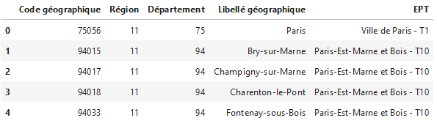

The data cleaning is quite straightforward:

* I keep only the column containing the cities’ names (column“Libellé géographique”).
* I remove the first row (the city of Paris) because I exclude it from the study.

Now I get a dataframe containing the list of cities in the Grand Paris area:

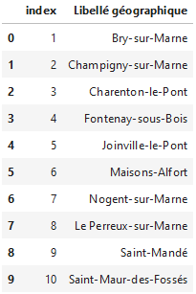

The dataframe contains 130 cities.

**Step 2: Add the geospatial data**

As mentioned in the “data” section, I want to identify the venues available in each city. For this, the Foursquare API proposes two possibilities:

* Either use the city name as input, in this case the API will send out all venue in this city.
* Or use latitude and longitude as inputs to the API, in this case the API will list the venues available in a given radius of this geographic point.

I tried both possibilities but in the principle, it makes more sense to list the venue situated in a given radius around the city center, so I go for the second possibility. This solution requires to the latitude and longitude of each city center. I use the geocoder python library to add the longitude and latitude in the previous dataframe:

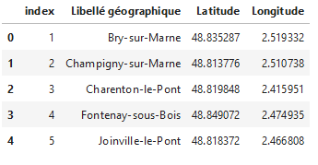

**Step 3: List the venues in each city**

I use the Foursquare API with an input radius of 2 000 m to list in a dataframe the venues around each city center:

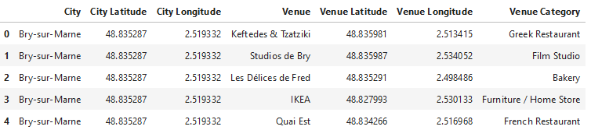

**Step 4: Group the venues by super-categories**

At this point, the Foursquare API provides us with too many venue categories, which in my opinion makes a good clustering difficult for my study. It would for example be much more relevant to group all restaurants, whichever their specialty they have, in a category "Food".

Foursquare gives us this possibility since super-categories are already defined in the developer section of their website: <https://developer.foursquare.com/docs/build-with-foursquare/categories/>

For example, the venues Amphitheater, Aquarium, Arcade, Art Gallery are grouped into a super-category called “Arts & Entertainment”:

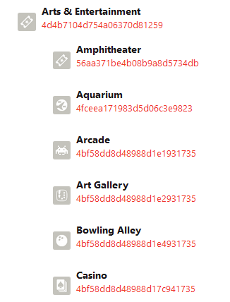

I create a function to make a table listing the venue categories and the super-categories they belong to, and save this table in a dataframe:

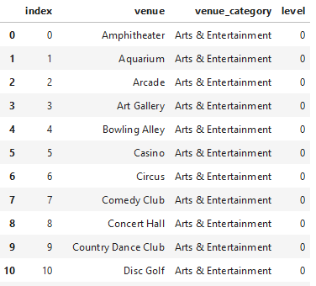

Note: the category also come with a level, which represents their position in a tree. I decide to keep only the level 0 super-categories, because I am only interested in the highest categories.

I then add these super-categories to my dataframe containing the cities’ names, their longitudes, their latitudes and their venues:

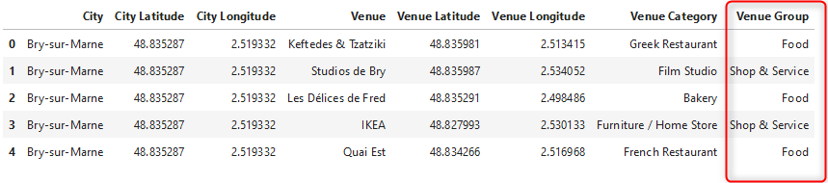

I notice that there are 8 super-categories:

* Food
* Shop & Service
* Outdoors & Recreation
* Travel & Transport
* Arts & Entertainment
* Nightlife Spot
* Professional & Other Places
* Residence.

**Step 5: Cluster the cities**

In order to meet the study target, determine which city fits the best with the inhabitants groups, I want to cluster the cities using a criterion based on these super-categories of venues.

I run the k-means to cluster the neighborhood into 4 clusters, which seems to be the best suited to define meaningful groups and I add the cluster labels to the dataframe listing the cities characteristics:

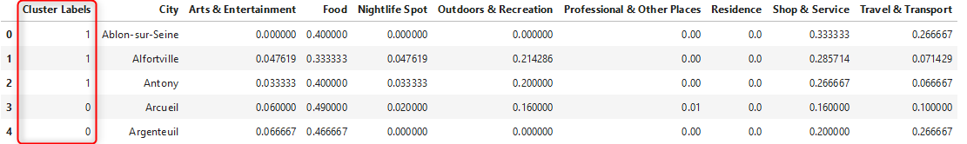

If I analyze the clusters, I notice that:

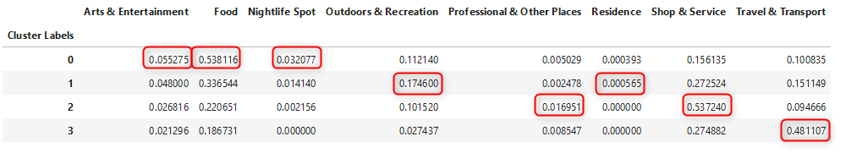

* The cluster 0 has the higher density for food, nightlife, Arts & Entertainment and is 2nd for the professional category, so I would recommend it to the students, young workers.
* The cluster 1 has more residence and outdoor and recreational areas, so I would recommend it for practitioners of outdoor activities and possibly retired people.
* In the cluster 2, there is a higher density of professional places, shops and services; I would recommend it to install companies, businesses.
* The cluster 3 is the best for Travel and Transport, so I would recommend it for the frequent travellers.

**Results**

If I represent the clusters on a map:

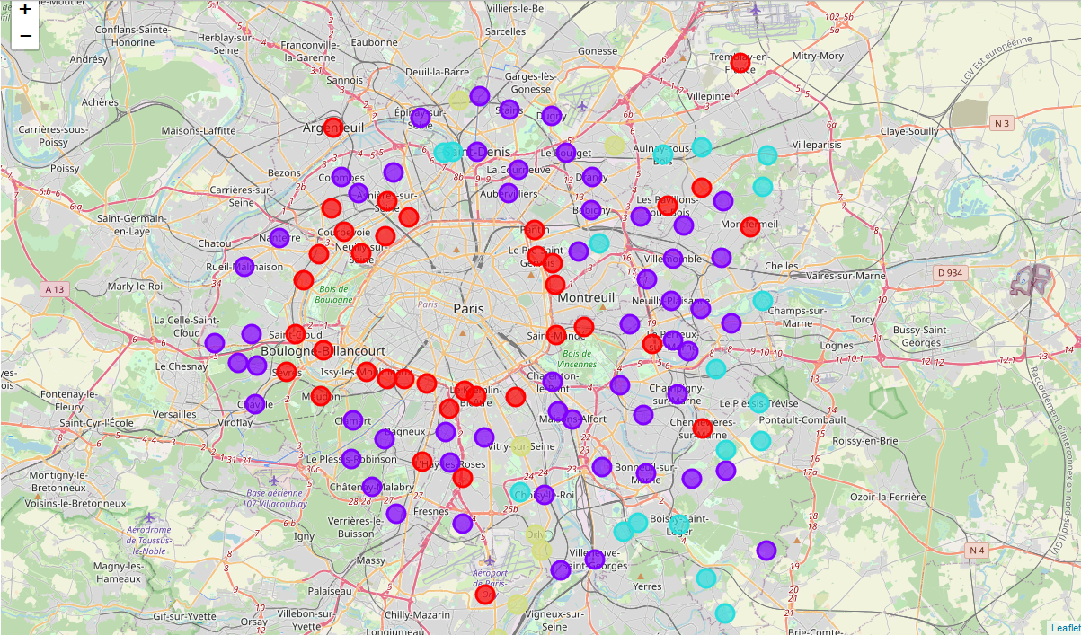

**Discussion**

I find some logic by comparing the map and the clusters:

* The first circle around (red dots) Paris in mainly made of cluster 0, it also corresponds to the most urbanized area.
* The outer area around Paris is the cluster 0 (purple dots) (recommended for practitioners of outdoors activities and possibly retired people), not a surprise since it is the least urbanized area.
* The cluster 1 (green dots) (recommended for frequent travelers) is composed of cities located close to the airports.

The results of the study are consistent with the basic knowledge that I have of Paris suburbs.

**Conclusion**

It is possible to determine by clustering the best areas to live depending on the individuals needs and centers of interests.

However, in the course of the study some limitations of this study appeared:

* The clustering is based on the relative distribution of each venues category in each city, but not based on their density. This means that a city with one restaurant as only venue for example will go into the cluster of cities where foods venues are majority, though its density of food venues is low. In order to solve this issue, a different encoding must be made.
* The Foursquare datasets are sometimes not comprehensive enough:
* In the Paris area, there is no venue of categories "College and Universities" listed, which makes it impossible to define a cluster recommended for families for example.
* The category "Residence" includes very few types of venues.

As next improvements, I would suggest:

* To improve the clustering by changing the categories used (either by using finer criteria or by adding criteria (like schools).
* Change the clustering criterion: rather based on venues density that on venues distribution in a given area.